

Cleft Lip & Palate

Department of Speech-Language Pathology

Phone: (843) 792-3251

|  |  |  |  |
| --- | --- | --- | --- |
| AGE | Speech & Language | Feeding & Swallowing | Notes |
| Prenatal to Birth |  | * Receive specialty feeding bottles* (ex: Dr. Brown’s specialty feeder) to have with you during baby’s birth | * Ultrasound at 18 weeks for early detection of cleft diagnosis * Meet with cleft team to answer any questions |
| 0-5 months | * Around 4-5 months baby will start making cooing - sounds like “oooo” and “ahh” * Short, simple babbling may be noted (e.i. “goo” or “ma”) | * Cleft lip (no palate invovled) usually do NOT exhibit feeding difficulties * Utilize specialty feeding bottles* * Milk may come through nose (normal) | * Cleft lip repair at 3 months or when baby reaches 10lbs * Weekly weight checks |
| 6-12 months | * Initial Speech Evaluation @ 12 months * Possible decrease in frequency and vocalizations following palate repair | * 4-6 months: introduce purees/soft solids. (Don’t delay based on cleft diagnosis, doesn’t need special permission from cleft team) * May need to reduce nipple flow rate * Milk may come through nose (normal) | * Cleft palate repaired by 12 months * After palate repair- it can take up to 6 months to fully regain function in muscles |



|  |  |  |  |
| --- | --- | --- | --- |
| AGE | Speech & Language | Feeding & Swallowing | Notes |
| 1-4 years | * VPI Testing* * Child may have fewer words * Focus on increasing amount of consonants used in child’s language * Encourage use of more sounds & a variety of sounds * Provide child with input by having them watch your mouth when you speak | * Your surgeon will have special instructions for feeding after repair * Eliminate straws after palate repair, and transition to sippy cups or regular cups after repair * Continue advancing textures | * Begin speech therapy if warranted by SLP |
| 4-6 years | * Therapy will target articulation errors and VPI* recommendations |  | * Secondary speech surgery if warranted |
| 6-12 years |  |  | * 8-10 years: bone grafting for fistula |
| 12-21 years |  |  | * Follow-up with craniofacial |

**Cleft Lip Cleft Palate Cleft Lip & Alveolus Cleft Lip & Palate Submucous Cleft Midline Cleft**

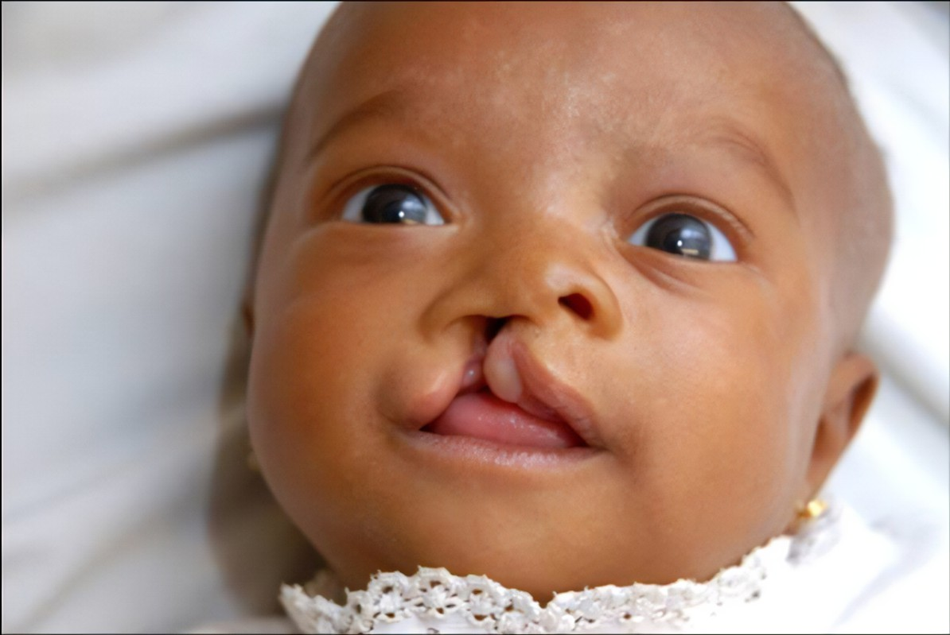 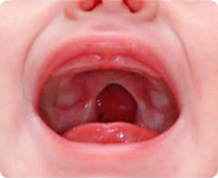 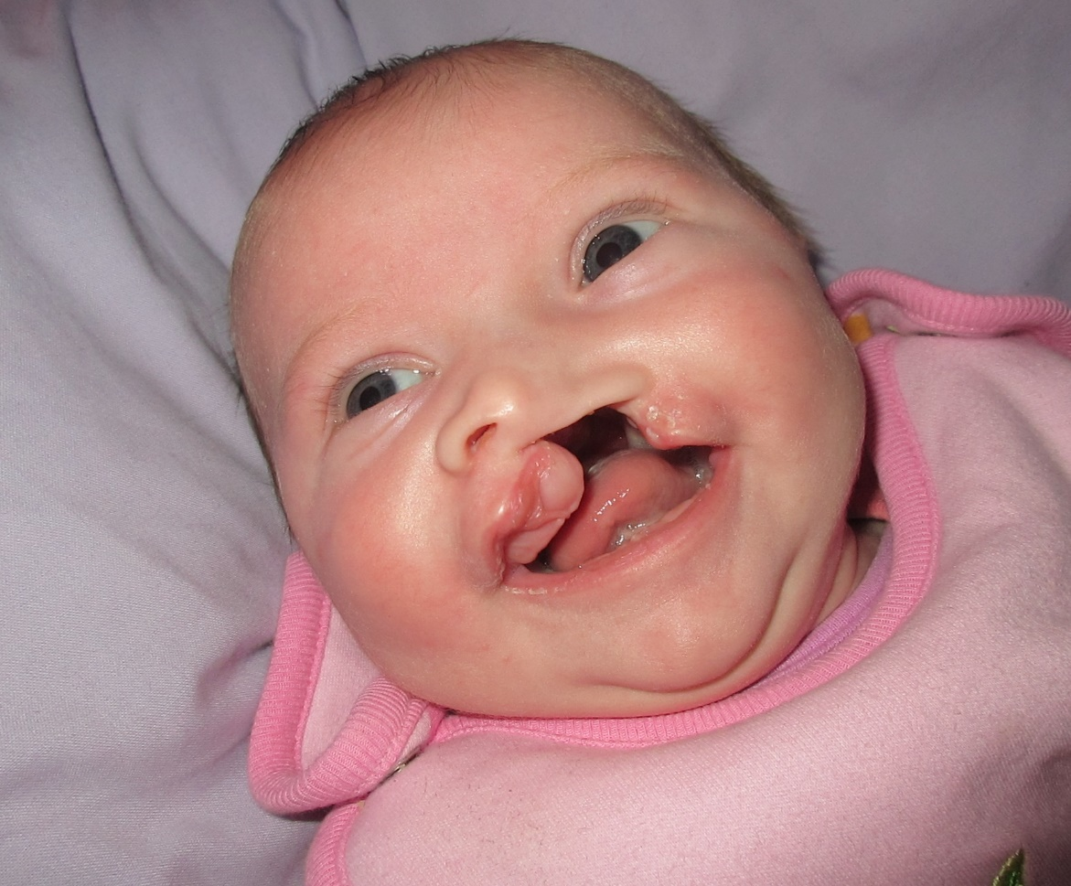 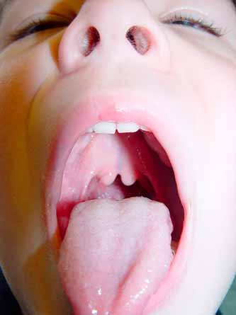

**\*Speciality Feeding Bottles for Cleft:** Bottles designed to decrease the amount of air entering when infant sucks and reduces the vaccum effect to ensure for easier feeding.

**\*Velopharyngeal Insufficiency (VPI):** describes an anatomic or structural defect that prevents adequate velopharyngeal closure. Adequate velopharyngeal closure is when the velum closes with the pharyngeal walls, allowing for separation between the oral and nasal cavities. When improper closure occurs it can lead to an increase in air leakage through the nose and creates hypernasal speech (more sound through nose instead of mouth).

**\*VPI Testing:** After a speech assessment, the SLP will determine if a child needs further VPI testing based on speech-sound production & if nasal air leakage/emissions are present. Testing will use nasometry, a computer-based instrument to measure nasal air emissions and compares it against normative values. In conjunction with an otolaryngologist (ENT) physician, nasopharyngoscopy (nasal scope) will allow for a visual of the speech mechism to determine if surgery is needed to correct the VPI.